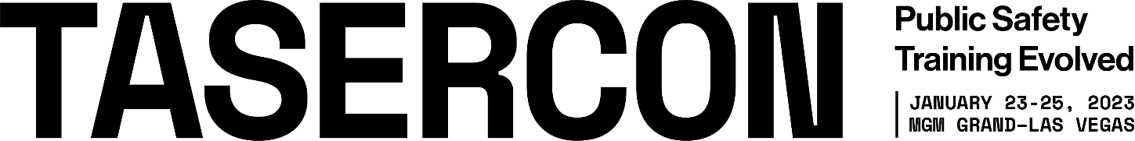

[TYPE THE DATE HERE]
[TYPE THE RECIPIENT’S NAME HERE]

This letter is to request approval to attend the TASERCON Conference on January 23-25, 2023, in Las Vegas, NV, USA. TASERCON is a first-of-its-kind, training conference to help agencies and officers perform at higher levels than ever, featuring a core conference curriculum focused on Protecting Life, Higher Performance, and Social Connection.

With more than 50 educational sessions, TASERCON is the only public safety conference to offer a full curriculum of training and education around saving lives, geared toward both educators, decision-makers, and professional development for public safety professionals.

It covers not just Axon technologies, but the biggest challenges that public safety faces today. Featuring experts like police trainers, educators, police attorneys, mental health professionals, and other public safety stakeholders, TASERCON is an unparalleled opportunity to come away with new strategies for higher performance, better community relations, and long-term impact.

I will have the opportunity to learn global best practices, establish new contacts with law enforcement leaders and make valuable connections with Axon and technology partners showcasing the latest in law enforcement products and services. When I return from the conference, I will share the new ideas, strategies, and techniques I learned to help our agency in the ever-changing policing environment.

I am sure you will agree that my attendance at TASERCON 2023 is a valuable use of my time and will benefit the agency and our community. Thank you for your consideration.
Sincerely,

[TYPE YOUR NAME HERE]
[TYPE YOUR TITLE HERE]
[TYPE YOUR AGENCY NAME HERE]

